**Abstract**

An enterprise network is a communications backbone that helps integrate and connect all systems within an organization. Enterprise network infrastructure provides the communications path and services between users, processes, applications, services and external networks. They are both local and wide area in scope. Enterprise networks are immensely important; yet, their design remains ad hoc and poorly understood.

An enterprise network design is a project that aims to show how systematic design how systematic design can handle key areas of enterprise network mainly: switching, routing, and server network.

The main objective of the project is to design a hierarchical enterprise network for businesses or organizations where principles such as modularity, resiliency, availability, and flexibility are applied. Real-time simulations and testing of the proposed network will be achieved through Cisco Packet Tracer.

**Keywords**: Enterprise network, routing, switching.

**Table of contents**

1. Network requirement analysis**……………………………………………………………….4**
2. Hardware and software requirement analysis**…………………………………………………………………5**
3. Network Topology Diagram and Explanation**…………………………………………………………7**
4. IP address design and documentation**……………………………………………………11**
5. Hardware inventorylist**…………………………………………….……………………..14**

**1. Network Requirement Analysis**

1. **Reliability:** The network provides 24/7 availability.
2. **Security:** The security of the network is secured, and provides reliable communication between the servers, and the branches also with the service provider.
3. **Availability:** The network can be available for users across the whole branches by satisfying end to end communications.
4. **Responsiveness**: The network provides efficient responses for user’s and server communication.
5. **Features:**

* Eliminate isolated users and work groups.
* Communicate and provide and retrieve information to all the computers in the network.
* Users can mail each other.
* Provide satisfactory performance, reliability, availability, and security.
* Facilitating the exploration and improvement of established enterprise communication protocols and strategies.
* Effectively combines and uses different device and system communication protocols.

1. **Network management and monitoring:** The network managed safely and monitored with strategies and software’s are used in designing a network.
2. **IP addressing:** Ip address network design is divided to main branch and other sub branches with reserved ip’s for all hardware components.

**2.Software and Hardware requirement analysis**

**2.1 Software Requirement Analysis:**

* Concept Draw Pro
* Packet Tracer
* Microsoft Visio

**2.2 Hardware Requirement Analysis:**

**Servers**: FTP, Database, DHCP, Email server.

**Routers**: 3-port routers (2911).

**Switches**: 24 port and two uplink port switches.

**Wireless Ap**: 250-meter coverage range wireless Ap.

**Cable:** copper cable.

**Firewalls:** Hardware firewall.

2.3 **Additional requirements:**

* Computer
* Printers
* Cables

**3. Services**

* **DHCP Service:** Dynamic hosting protocol services enables server to assign an Ip address automatically with a given specified range to the connected devices or hardware devices.
* **Database Sharing:** Sharing of database for all branches.
* **File Transfer Protocol (FTP):** This service provides sharing of files between the server and user. Easy file sharing achieved.
* **Email:** This service uses mail server and achieve mailing of users each other in across the whole network.
* **Static NAT service:** static NAT we can translate private IP addresses to public addresses. Each private IP address is mapped to single public address. This service is configured in the router that connects the main branch to the internet.
* **Local print sharing –** To share printer by all users in one office.
* **Wireless Access:** This service provides wireless communication for the laptops and cellphones available in each office.
* **Failover cluster:** Failover cluster service is configured in  
  group of servers that work together to maintain high availability of application and services. Failover cluster is configured in server center in main branch.

**4.Network Topology Diagram and Explanation**

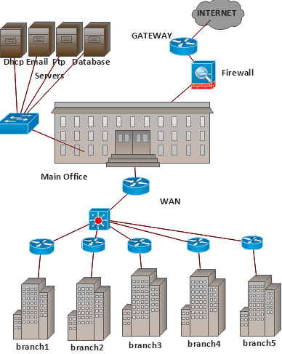

* 1. **Explanation of WAN Network Topology**

The main branch consists of 4 servers that can be accessed from all branches these servers are:

* FTP server- is used for file transfer.
* DHCP server-is used to configure ip address automatically for all user.
* Email server-is used to provide email service.
* Database server-is used to share database to all users throughout all the branch.

The main branch is also connected to the internet in order to provide internet connection for the users. All users can access to internet through main office.

Each branch is connected to main office by wide area network (WAN). This WAN connection is built by fiber optic cable in order to maintain fast connection.

The Network also consists of a firewall that are capable of checking for any security threats and protecting the servers from any attacks.

IP address is assigned to each branch by subnetting the address in the way that all users in every LAN are connected.

Routers are used to connect the LANS from branches to the main office.

Switches are used to create hierarchical network from top down and to connect the servers with the main and branch offices.

* 1. **LAN Network Topology**

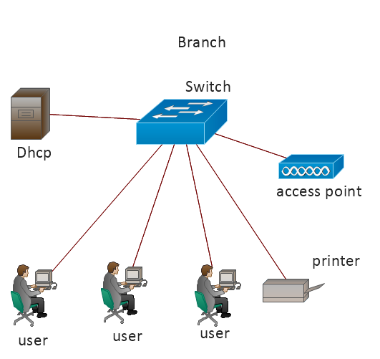

* 1. **Explanation of LAN Network Topology**

In LAN there are many users that connected to the network using a switch, and there is also DHCP server that gives automatically Ip addresses to the users or devices connected to the switch this can be achieved through a given subnetted Ip address range.

Printer services also provided in all branches in our network topology, and also wireless AP that used for connecting devices without wired.

All the five branches share the same thing one from each other, Inspite of the subnetted Ip address ranges, and number of user’s branches are the same in configuration.

**5. Ip Address Design and Documentation**

The organization uses private address and uses public address for internet.

We are assuming that:

**Main Branch**: can have up to 16,384 users and also 16,384 reserved ip addresses for the future if the company becoming wide.

**Branch 1**: 4096 users and also 4096 reserved ip addresses.

**Branch 2**: 4096 users and also 4096 reserved ip addresses.

**Branch 3**: 4096 users and also 4096 reserved ip addresses.

**Branch 4**: 2048 users and also 2048 reserved ip addresses.

**Branch** 5: 2048 users and also 2048 reserved ip addresses.

So totally we have 65,536 estimated ip addresses needed. So as to satisfy these number we need to have /16 block of address and also private address that uses for a company.

The main branch has greater usable and reserved ip address than the others this is because of the workers at the main site is greater than the other sides.

**Subnetting**

We choose an ip address that is in the range of private ip addresses.

The ip block is 10.72.0.0/16

216=65,536

This ip block can be used for this company.

|  |  |  |
| --- | --- | --- |
|  | Usable | Reserved |
| Main Branch | 16384 | 16384 |
| Branch 1 | 4096 | 4096 |
| Branch 2 | 4096 | 4096 |
| Branch 3 | 4096 | 4096 |
| Branch 4 | 2048 | 2048 |
| Branch 5 | 2048 | 2048 |

|  |  |
| --- | --- |
|  | Ip Range |
| Main Branch | 10.72.0.0-10.72.127.255 |
| Branch 1 | 10.72.128.0-10.72.159.255 |
| Branch 2 | 10.72.160.0-10.72.191.255 |
| Branch 3 | 10.72.192.0-10.72.223.255 |
| Branch 4 | 10.72.224.0-10.72.239.255 |
| Branch 5 | 10.72.240.0-10.72.255.255 |

**Logical Configuration**

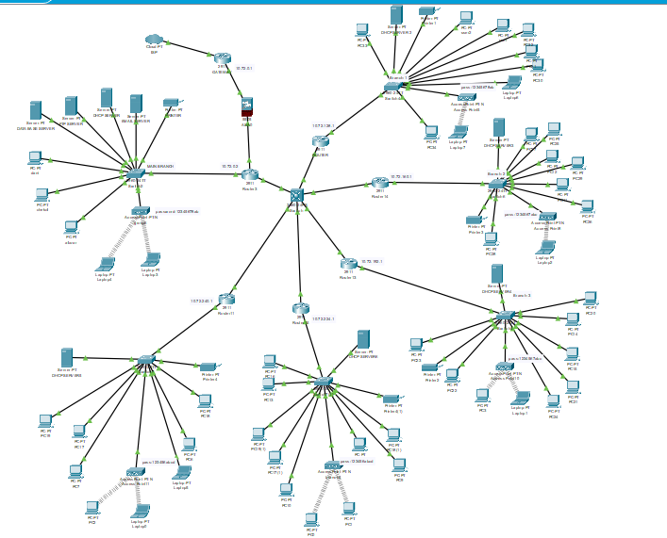

**6.Hardware Inventory List**

|  |  |  |
| --- | --- | --- |
| Hardware | Quantity | Cost |
| Switches | 7 | 1750 |
| Servers | 9 | 18,000 |
| Routers | 7 | 5,950 |
| Cables | - | 120,000 |
| Wireless Router | 6 | 120 |
| Firewall | 1 | 250 |